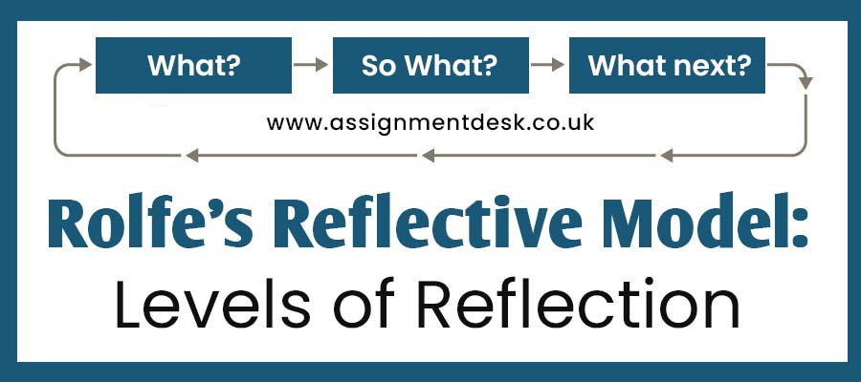

What? So What? Now What?

These three primary and topmost questions indicate what we will discuss next. The writing of the Rolfes stated that it is essential to consider the reflection after the event and focus on the examination at the moment.

As a student, it is standard that you must know about Rolfe's framework for reflective practice as **rolfe et al reflective model.** It is the model that wholly and completely revolves around the three big questions. However, several students need help understanding what it is and how it works. So to solve every query, we bring this blog. With this blog's help, students can learn the basic information about **Rolfe reflective model** and its usefulness in writing reflective practice assignments. However, before moving ahead, students must know what it is and how it works.

What Is Rolfe's Framework For Reflective Practice?

Rolfe's framework is one of the reflective cycle and reflective practice types. In several universities, nursing students are assigned assessments based on Rolfe's framework for reflective practice. The primary purpose of the **Rolfe reflective model** is to relate to simplicity and clarity. Therefore the reflective tools need to be accessible and valuable to the user. It helps to produce meaningful results. It is one of the simple models that can support that. Writing assignments for the reflective practice cannot be easy. Even students need to focus on the three main questions. They are:

What?

So What?

Now What?

The above stated are the three basic questions on which the Rolfe reflective model acts. Still have doubts and need to get the correct answer to the problem, then know about the evaluations of this model. It will provide you with a clear understanding of the model.

## An Evaluation of the Model

One main advantage is that the **Rolfe reflective model** relates to the basic simple and provides clarity. Therefore, the issues related to the model include the concept of the three core questions, as we have mentioned above. This is one of the procedures on which the whole inventory of the situation is being reflected and may take place elsewhere. Also, the insight did not produce the consequences that might tend to the descriptive or in simple form.

According to Rolfe's writing, it is vital to contemplate reflection not just after the occurrence but also in the time - as the event is happening - so that quick remedial action may be taken. For Rolfe, however, because of its simplicity, this model only partially defines the perspective; reflection is not merely a summary process but must be engaged proactively (**rolfe 2001 reflective model**).

## Three Steps of the Rolfes Model of Reflection

Below are the main questions that help represent the different stages of the given scenario. Also, these three questions (What?, So What?, Now What?) are the main questions. They also have some sub-questions that help to describe the situation. Have a look at the three steps of the **Rolfe model of reflection**.

### 1. What?

What helps to describe the presented situation in front of you?

What is the main reason or issue that you get stuck with?

What is my primary role in creating the situation at that time?

What was I trying to achieve?

What were the significant responses of others?

What were the actions that were being taken?

What are the consequences for me?

What were the consequences for others?

What feelings were provoked?

What feelings were provoked inside me?

What feelings were provoked in other people?

What was optimistic about the entire experience?

What was pessimistic about the entire experience?

What could be improved in the experience?

### 2. So What?

So what helps to provide information regarding the interaction with the one situation and how it affected you?

So, what do you mean to say about my relationships with others?

So, what was my thinking process when I acted in the situation?

So, what was the base of my course of action about that situation?

So, what are the significant approaches I have deployed to the situation?

So! What could be done extraordinarily in that particular scenario?

So! What brings out the best learning from the incident?

So! What novel are issues highlighted here in the situation?

### 3. Now What?

Now What describes the plan or, we can say, the action you will devise after analysing the situation and self-reflection?

Now! What should be the next move to improve things for betterment?

Now! What help would be required to fix the things?

Now, what things should I avoid in the future?

Now! what have I learned from this experience?

Now, what have others learned from this?

Now! What areas to address for improvised actions?

Now, what broader conversations need to be considered?

For this reason, these are the set of questions to form an excellent tool for understanding various situations. So by applying all the questions in the perfect format or scenario, students can know better ways to handle it in the future. Let's take the help of an example: if we apply all the mentioned questions to the nursing case, then the sub-questions would look different when we use them for personal life crises.